Pre-workshop assessment on implementation of
Health in All Policies and Intersectoral Actions

Population health and health inequities are shaped by a broad range of societal, environmental, economic, cultural and political factors that sit outside the remit of the health sector. Taking action across sectors (in government and in society) to protect and promote health is therefore required to address the determinants of health and health inequities.
The actions can take many forms, and are inherent to several terms being used, such as “intersectoral action,” “multisectoral action,” and “health in all policies.” Working together across sectors to improve health and influence its determinants is often referred to as intersectoral action for health (ISA). The objective of ISA is to achieve greater awareness of the health and health equity consequences of policy decisions and organizational practice in different sectors, and move in the direction of healthy public policy and practice across sectors.
ISA can be defined as “a recognized relationship between different sectors involving interaction in the form of information, cooperation, coordination and/or integration to take action to improve health and health equity”.
“Health in all policies (HiAP) is an approach to public policies across sectors that systematically takes into account of health implications of decisions, seeks synergies, and avoids harmful health impacts in order to improve population health and health equity. As a concept it reflects the principles of legitimacy, accountability, transparency, and access to information, participation, sustainability, and collaboration across sectors and all levels of government.” HiAP can be seen as a continuum of ISA that often involves systematization, formalization or institutionalization of the approach.
Reporting Progress
Based on your knowledge and best capacity in the position you involved in your current position, please provide appropriate answers. There are 4 sections of the questionnaire.
- Perceived actions and perspectives of ISA/HiAP implementations
- Mechanisms and enabling factors
- Capacity & Evidences
- Monitoring and tracking success

- Perceived actions and perspectives of ISA/HiAP implementations
Based on this Model, please response to questions below by rating degree to which you perceived as normal interaction and relationship your organization has with other sectors.  (1= agree, 2 = somewhat, 3 = disagree, 4 = not applicable/no knowledge) | 1 | 2 | 3 | 4
- Information are often shared with other departments and/or across sectors.
- Cooperation with other departments and/or across sectors was done to achieve greater efficiency for the actions/interventions.
- Cooperation with other departments and/or across sectors was done to optimize used of resources and sustainability.
- Coordination with other departments and/or across sectors often made to increase horizontal network to share financing resources, adjust policies and programmes of each sector.
- Most of national programmes and policies are represented by multiple partners from different sectors.
- Most of sub-national programmes and interventions are represented by multiple partners from different sectors.
- Most of national programmes and policies systematically integrated in their objectives, administrative process, resources, responsibility and actions to achieve optimal health outcomes and/or social equity.
- Most of sub-national programmes and policies systematically integrated in their objectives, administrative process, resources, responsibility and actions to achieve optimal health outcomes and/or social equity.
- Health in all policies has been adopted in the national strategy or national health policy.
- HIAP has not been adopted nationally, but it is needed to address health determinants and inequities.

- Mechanisms and enabling factors

Please response to these items from your knowledge and experiences on what actually happened | Yes | No
- Does your country have systematic process for different sectors to work together on an issue, or a national agenda?
If yes, please specify programme you know or familiar with…………………… ……………………………………………………………………………………………..
- Does your country have clear mandate for intersectoral policies, e.g. constitution, legislation, development framework, etc,?
If yes, please specify policy (ies) you know or familiar with…………………….. ……………………………………………………………………………………………..
- Does your organization operated on joined-up government policy or programme?
If yes, please specify the programme ……………………………………………………………..
- Has your organization experience working with other sectors or stakeholders outside the government?
- Is it mandatory for your organization to work across sectors and build partnership?
- Do you know whether your country has intersectoral committee(s) with statutory responsibilities for health, public hearing, consultation, or coalition that make impact on health and equity?
- As per your knowledge, do you think your country has explicit strategies to engage with multisectoral partners in policy discussion to reduce health inequities at local, subnational, or national level?
If yes, please specify which level …………………………………………………………..

- Capacity & Evidences

Please response to these items from your knowledge and experiences on what actually happened | Yes | No
- Do you have experience in assessing the health impacts of policies?
If yes, please specify the policy……………………………………………………….
- Does your country integrated health impact assessment into policy development process?
If yes, please indicate an example of policy ………………………………………
- Does your country has training institute involved in “health in all policies” implementation and/or engaging with multisectoral policy development?
- Do you implement “health in all policies” approach in your organization/setting?
- Has your organization produce report linking health and other determinants of health?
If yes, please specify the study………………………………………………………………..

- Monitoring and tracking success
Please response to these items from your knowledge and experiences on what actually happened | Yes | No
- Does your country have routine monitoring and evaluation of intersectoral policies, or actions across sector?
- Does the monitoring and evaluation process in your country normally involve multisectoral partners?
- Does the success of intersectoral actions for health and health equity shared by multisectoral partners?

Please provide the following information of the person who response to the questionnaire (confidential)
Name of Organization………………………………………………………………………………………………………………
Title/Position ………………………………………………………………………………… Date………………………………

Please send response back to
goods@who.int
WHO-SEARO/HPE/NDE
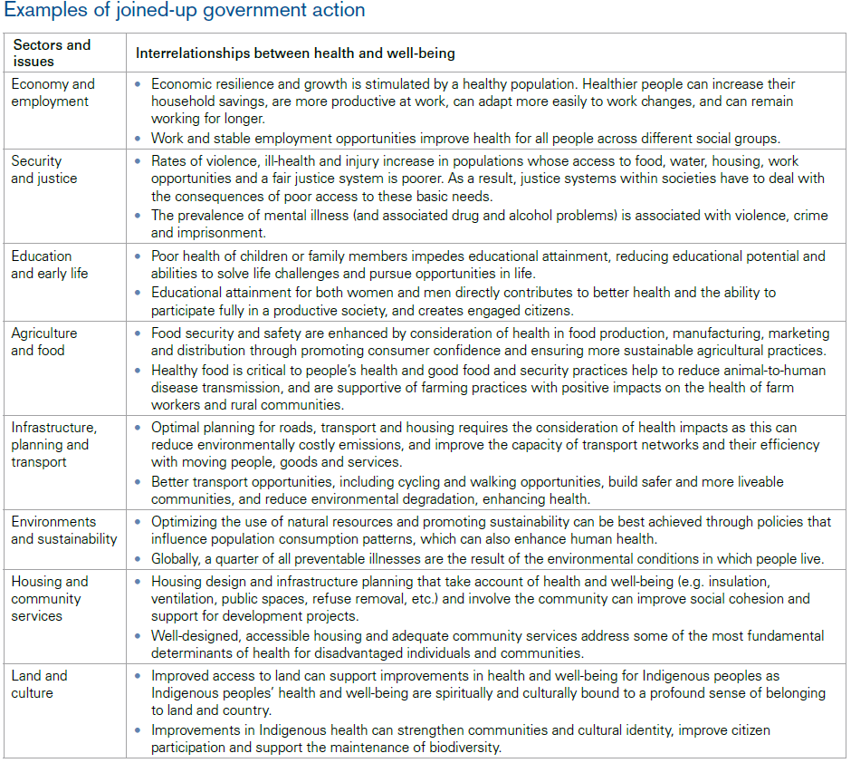
Adelaide Statement on Health in All Policies. WHO, Government of South Australia, Adelaide 2010.

Intersectoral action on Health. A path for policy-makers to implement effective and sustainable action on health. WHO Centre for Health Development, Kobe, 2011.
Health Equity through intersectoral action: an analysis of 18 country case studies. WHO and Public Health Agency of Canada, 2008.
Health In All Policies (HiAP) Framework for Country Action, World Health Organization, 2014
Intersectoral action on Health. A path for policy-makers to implement effective and sustainable action on health. WHO Centre for Health Development, Kobe, 2011.

